Full Name |  | Preferred Title Mr/Mrs/Miss/Ms/Dr
Tel. No. |  | Mob. No.
Address

E-Mail |  | D.O.B.
Where did you hear about volunteering for The Dovetail Project?
What activity or subject would you like to share at a session or sessions?

How would you like to share this? (we can help you with this, if you are unsure)

How often would you like to, or could you, share at our sessions? (Please circle)
Once Once every 3 months Once a month Not sure
Do you identify as a Christian?
Yes / No Current Church (if applicable):

(Please note, it is not compulsory that Sharers are Christians, however, as a Christian organisation, you must be able to appreciate and respect our Core Values)
Do you have any Criminal Convictions (other than minor driving offences)? Yes / No
Do you have experience working with adults with learning difficulties? Yes / No
(Please note, this is not compulsory)
Would you interested helping us in other ways? If so, please complete the table below.
Your skills and interests |  | Areas which may interest you
Admin / Clerical |  | Admin / Clerical
Arts and Crafts |  | Leading a session
Car Owner |  | Contact and connect with churches
Computer Skills |  | Session Assistant (helper)
Driving |  | Hospitality support
Form Filling |  | Discipleship
Fundraising |  | Community events helper
Communicator |  | Fundraising
Practical (DIY, Gardening, Shopping) |  | Become a Trustee of David’s Table
Other – Please Specify |  | Other – Please Specify
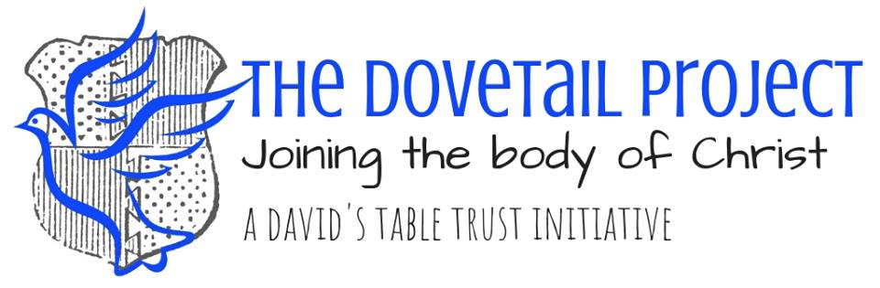
Session Activity Sharer
Sharer Enquiry Form

Further information (optional)
Experience as a Volunteer

Work Experience
Courses or Training (if relevant)

Hobbies and Interests

The information given on this form is confidential and covered by the Data Protection Act 1998 and General Data Protection Regulation 2018.

In order to comply with UK Data Protection Legislation, we need to ensure that we have your permission to store your personal information on our database.

I CONSENT for my personal information to be stored for the purpose of providing volunteering activities:
YES □ NO □

The Dovetail Project, would like to keep you updated about services, news, activities and events for volunteers. I CONSENT for my information to be used for this purpose
YES □ NO □

I CONSENT to being contacted by the Dovetail Project by (circle ALL that apply):

Email Telephone Post

I would like to subscribe to the project’s e-newsletters and I understand I can unsubscribe at any time by clicking ‘unsubscribe’ on the email or contacting info@davidstable.co.uk.

Signed

Print name

Date

PLEASE READ AND SIGN OUR CORE VALUES, OVERLEAF.

The Dovetail Project
Elizabeth Lodge
Trowbridge
BA14 0HS
www.davidstable.co.uk/dovetail

Our Vision
To join the body of Christ in the Trowbridge area, to enable isolated Christian’s with learning difficulties to experience the fullness of God’s kingdom on earth, develop their understanding of His love, plan and purpose for them and to build relationships with the wider community.

Our Central Purpose and Mission

The project aims to join the body of Christ together, through visits from Christians, Church leaders in the local area and the general community, as well as nurturing friendships between each Dovetailer. We aim to promote the spiritual growth of our Dovetailers, through sharing the teachings of Jesus and biblical principles in a simple and creative way. We provide purposeful activities to enhance our Dovetailers skill set and give them a tangible reward for their hard work that will increase their confidence and independence.

Our Core Values

J We ensure Jesus is at centre of all we do.
O We wish to provide opportunities to our Dovetailers and the community beyond.
N We aim to build a network of people to provide fellowship, friendship and community.
A We provide purposeful activities for our Dovetailers to enhance their skills.
H We aim to provide a homely, safe and loving environment for all involved in the project.

I agree to support the mission, aims and core principles of The Dovetail Project.

Full Name: …………………………………………………………………………………………………

Signature: ……………………………………………………. Date: …………………………………..

Our Activity Sharer Enquiry Form is overleaf. If you are interested in sharing at our sessions, please complete both sides of this form and return to a member of David’s Table Trust staff or to the address below. Many thanks!

